**CRUZ-RABE PHARMACY REQUEST SYSTEM**

Cruz-Rabe Maternity and General Hospital

Developer: Bueno | Rosales

MSYADD1 @ Asia Pacific College 2016 – 2017

**Project Professor:**

* Mr. Manuel Sebastian Sanchez MSYADD1 Class Professor

**Project Consutant:**

* + Dr. Manuel Calimlim Jr. SoCit Professor
  + Mr. Alfredo Calimbo SoCsit Professor

**Project Adviser:**

* Mr. Jayvee Cabardo Director, Education Technology

**Project Team:**

* Carl Dominique Bueno Project Manager/Developer
* Glen Roy Rosales Project Analyst/Documenter

**Client Information:**

Compant/Organization Name: Cruz-Rabe Maternity and General Hospital

Project Name: Cruz-Rabe Pharmacy Request System

Primary Contact Person: Carmelita Buenaflor

Position: Chief Pharmacists

**Health Facility Detailed Information:**

**ACCREDITATION NO:** H92007290   
**PMCC NO:** 313634   
**INSTITUTION NAME:** Cruz-Rabe Maternity and General Hospital   
**ROAD NAME:** 37 Gen. Luna Street   
**BARANGAY:** Tuktukan   
**MUNICIPALITY:** Taguig City   
**PROVINCE:** Metro Manila (SOUTH)   
**REGION:** NCR (SOUTH)   
**CATEGORY:** Level 2   
**CLASSIFICATION:** Private

1. **Introduction**

### Project Context

### In order to ensure patient's safety, cost effective processes and well managed admission on managing medical services, through preventing clinical errors and use resources efficiently*.* Therefore, business process should have a sufficient tool which is an automation of *“Pharmacy Request System.”* Transactions that are processed in different factors including; *IN* and *OUT* patient order entry, *dispensing orders,* *pharmacy inventory* and *purchasing management* will stand-alone by providing innovative way of service. The client *Cruz-Rabe Maternity General Hospital* uses the latest technology enabling *complete control* to improve medical management and to bring satisfaction to their clients in terms of *professional service.*

#### Success Factors

We can assume that the system will be feasible if the proponents meet the following requirements:

* If the system seems to be helpful when hospital transactions (pharmacy requests) are now processed in just a few moments.
* If the results produced are accurate and reliable for the patients.
* If the pharmacy records can be tracked down easily from its database.
* If less resources are utilized but service would improve.

We can assume that the system will be successful for a long term if we meet the following requirements:

* If the system is useful to patients and hospital staffs in terms of service, performance and satisfaction.
* If it will generate enough revenue to support the maintenance of the system.

**Business Risk**

**RI-1:** Might take in critics since the pharmacy department will be adapting changes towards its business transactions.

**RI-2:** It will require equipment and services in order to produce the system. This means, the organization need to invest in this project as there is a possibility to make changes in certain aspects such as its maintenance and security.

### Purpose and Description

A pharmacy within a hospital case, wherein there will only be IN and OUT patients for pharmacy request entry.

The system will have the following:

* Order Prescription
* Patient History Records,
* Stock Inventory of Medicine and Supplies Directory
* Department Directory
* Doctor Directory

#### Purpose and Success Factors

**P1:** Make the processing of prescriptions faster and reliable

**P2:** Lessen the loss of data of the existing and upcoming pharmacy records

**P3:** Increase efficiency of work in input of information and processing of requests by the pharmacists upon implementation

**S1:** The pharmacists are able to maximize productivity with the use of the Pharmacy Request System (PRS)

**S2:** Receive a positive feedback from the client regarding the increase average amount of work done by the Pharmacy Department

**Objectives**

#### General Objectives

* Paperless Transactions System (PTS)
* Automation of Pharmacy Request System
* Convenient way of discharging patients

#### Specific Objectives

* Eliminate mistakes caused by manual steps and workarounds
* Pharmacy transactions will be generated electronically for accessibility
* Pharmacy system will be more reliable and convenient
* Less tedious on data mining and documentation
* Save and track relevant information in real time

**Vision Statement**

A *Web-based system* for processing *pharmacy request* within a system, dedicated to ease the way of accepting requests by pharmacists to process the *automated prescription orders* and *dispense orders* in a better way. It will not only verify the information received, but also keep the records in a secured database which can be accessed for future preferences. Unlike the old-way of *manual processes*, *Cruz-Rabe Pharmacy Request System* intends to improve the quality of work in the medical field by providing the essential steps of transactions in fast-pace. *The vision of this system is determined to meet patient’s satisfaction in terms of service.*

**Scope and Limitations**

Pharmacy Request System is intended for pharmacists to use in their service that assists patients’ drug requests that is prescribed by a doctor. Alternatively, the Pharmacy Requests will be automated and the data will be on a database for data warehouse. This scheme will ease the work of the auditing staff and improve the discharging process of patients.

#### Assumptions and Dependencies

**AS-1:** Additional equipment, services, and maintenance will be improvised for the authorized personnel to do the business processes.

**AS-2:** The hospital will be developed to ensure the system was implemented well-lesser hardcopies, more softcopies for the records.

**DE-1**: If the pharmacy records will be accessible with the other departments to support the system for consistency of the data.

1. **Related Literature**



***Omnicell*** is recognized as a leading provider of comprehensive, technologically advanced automation that enables health care facilities to acquire, manage, dispense, and deliver medications and supplies more effectively. Omnicell automation is used from the point of entry into the hospital through the central pharmacy, nursing units, operating room, procedural areas, and patient bedsides – as well as in long-term care sites. For over 20 years the mission of Omnicell has focused on improving the medication and supply distribution process.

More than 4,000 acute care customers worldwide have used Omnicell’s medication automation, supply chain, and analytics solutions to improve efficiency, reduce errors, and lower costs. Omnicell non-acute care solutions, including the MTS brand, enable approximately 7,000 institutional and retail pharmacies worldwide to optimize productivity and control costs. Moreover, the innovative medication adherence packaging solutions can reduce costly hospital readmissions.

At Omnicell, delivering our technology is just the beginning. We are also committed to delivering the best customer experience. To ensure our customers gain the most utility from their Omnicell systems, we offer a suite of analytics software, a comprehensive training and education program, and first-rate customer support. Omnicell has been recognized with KLAS award every year since 2006.

Key product lines:

* Central pharmacy automation
* Medication management systems
* Supply management systems
* Business analytics
* Medication adherence packaging



***PioneerRx Pharmacy System*** is a windows-based ground-breaking pharmacy software. Cutting edge features include the Apple iPad Signature Capture, Email/Text Customer Notification, Hard Copy Imaging Workflow and more.

Developed with the experience of over 30 years of pharmacy software development and support, PioneerRx was built from scratch to provide the pharmacy community with a solution that can grow as the industry changes for the next 40 years. These features are designed to provide speed, simplicity, consistency and flexibility. However, our ultimate goal of development is to help pharmacies make more money.

Many features and benefits of PioneerRx that can help improve your pharmacy:

* Mobile Delivery offers an easy, secure and fun way for drivers to complete transactions, take payments, and store patient signatures while on a delivery.
* Advanced Searching throughout PioneerRx advanced search grids offer user-friendly options for pulling data such as custom layouts, fixed rows and columns, sorting, filtering and exporting.
* Apple iPad Electronic Signature Capture. Prepare for audits and impress your customers with the latest technology by capturing signatures on your Apple iPad or iPad Mini at the Drive Thru.
* Prescriber Add/Edit from NPI/DEA Database. PioneerRx supports seamlessly adding prescribers or updating their information from the National Provider Registry and DEA database. Never wait for hours to get a DEA number again.
* Integrated Pre/Post Edit. Pre and post edits are included in your PioneerRx software. Discover opportunities for increased payment due to errors such as Package Size, DAW, Obsolete NDC, and more.
* RxNotify. Send email, text and IVR messages when prescriptions are ready. Provide your customers with great service and keep your will call bins empty by using RxNotify.
* Modern Windows System. PioneerRx was built from scratch to take advantage of the capability and strengths of a modern Windows environment, including dashboard screens and Microsoft's ribbon bar navigation.

1. **Technical Background**

#### Major Features:

**F1:** Purchase medicine and supplies conveniently within the pharmacy  
**F2:** Do inventory check easily for tracking down changes on stocks  
**F3:** Discharge patients with electronic records  
**F4:** Check the validation and availability of the requests  
**F5:** Secure the authorization of the pharmacists and authorized personnel to do the process  
**F6:** Send the information throughout the other departments electronically

1. **Appendices**

**EVENT TABLE**

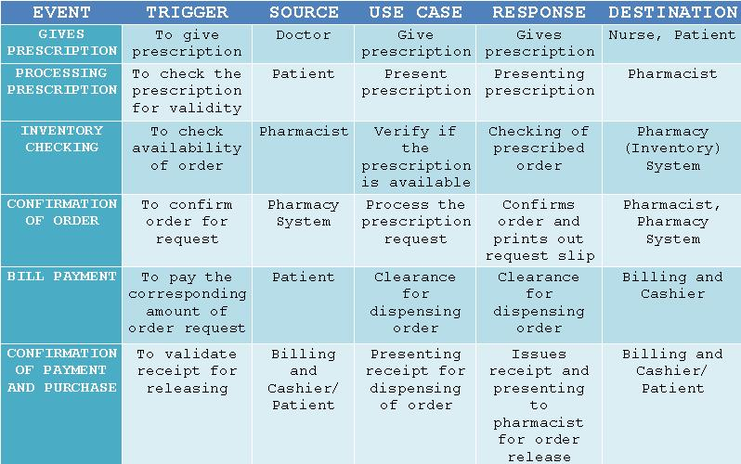

**USE CASE FULL DEFINITION**

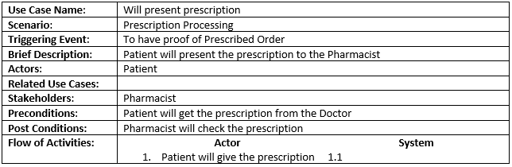

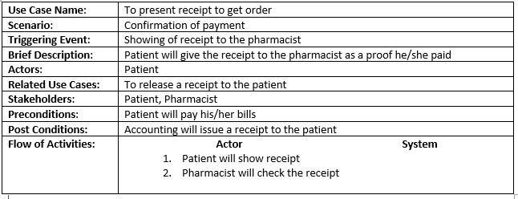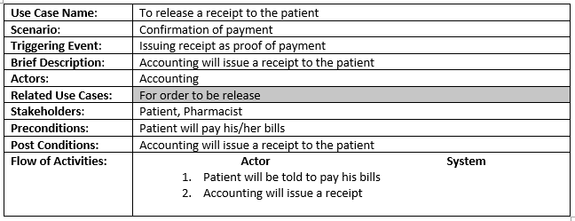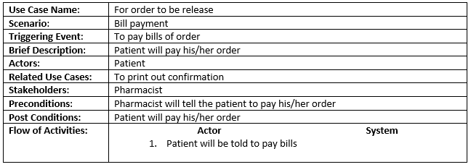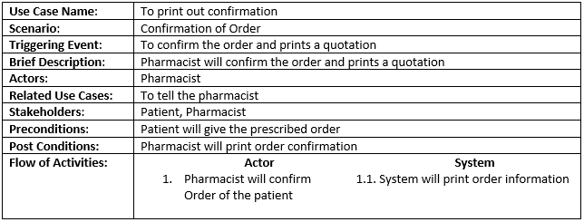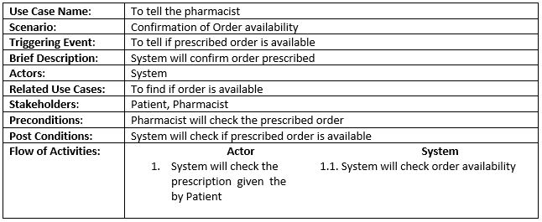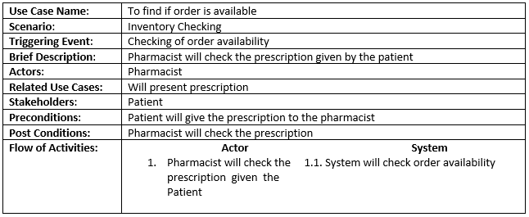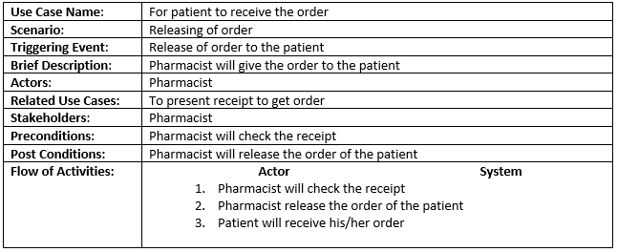

**ACTIVITY DIAGRAM**

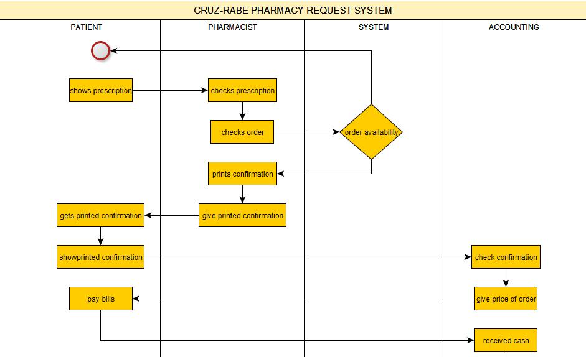

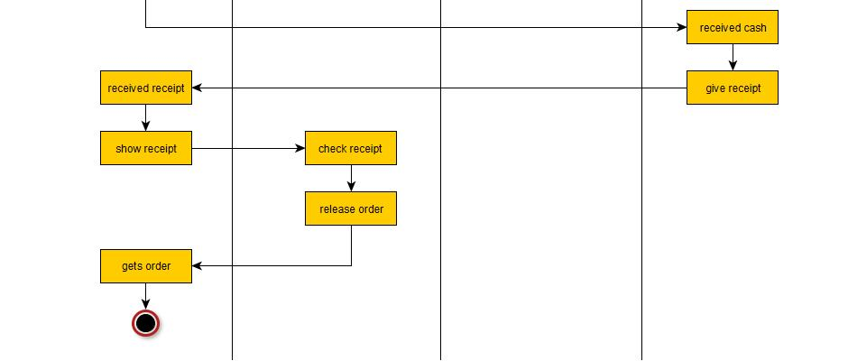

**CLASS DIAGRAM**

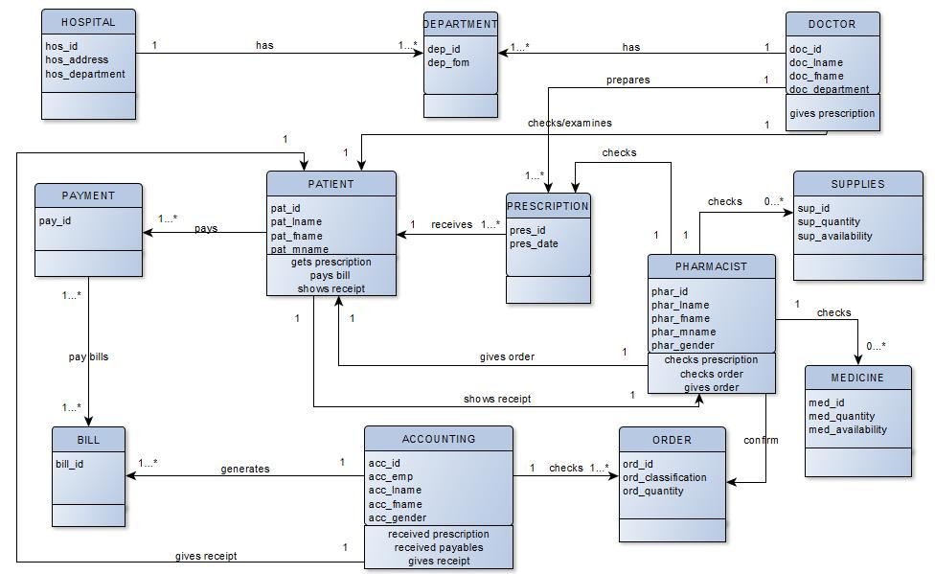

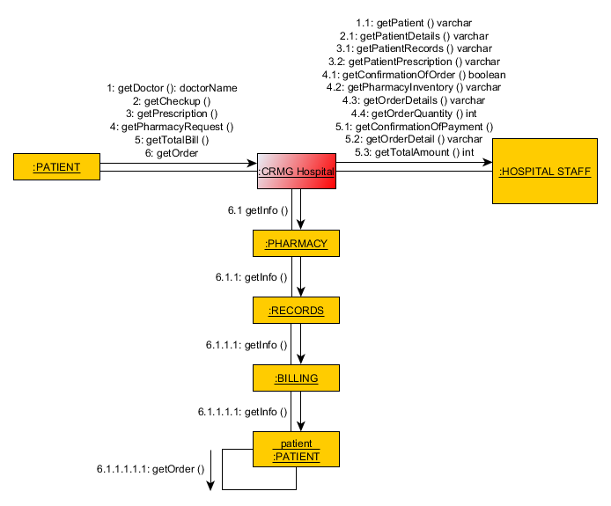**COMMUNICATION DIAGRAM**

**COMPONENT DIAGRAM**

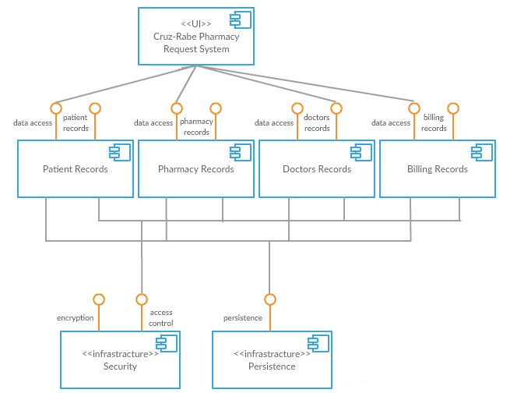

**COMPOSITE STRUCTURE FLOW**

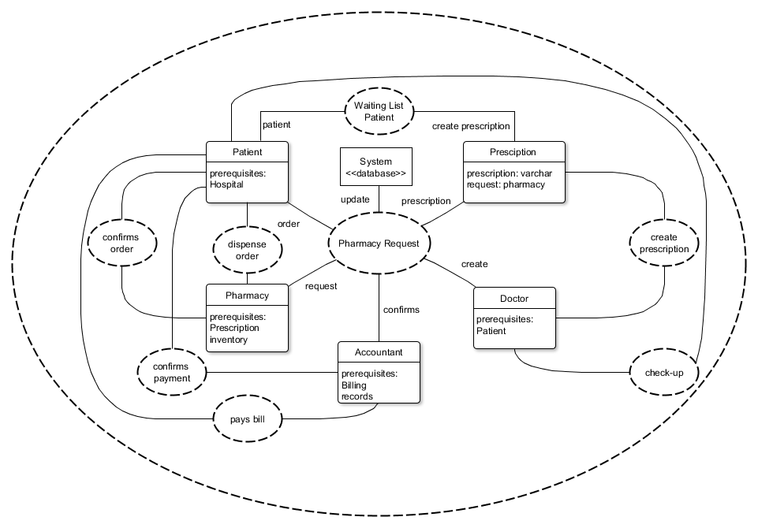

**CONTEXT FLOW DIAGRAM**

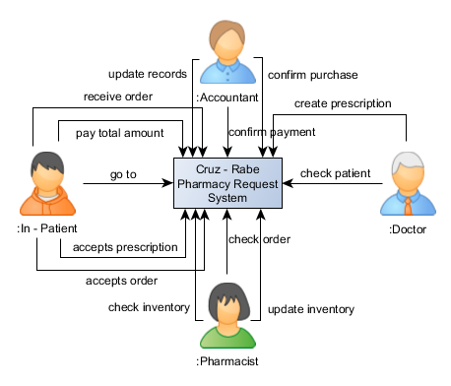

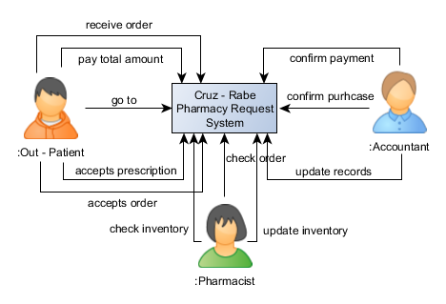

**DATA FLOW DIAGRAM**

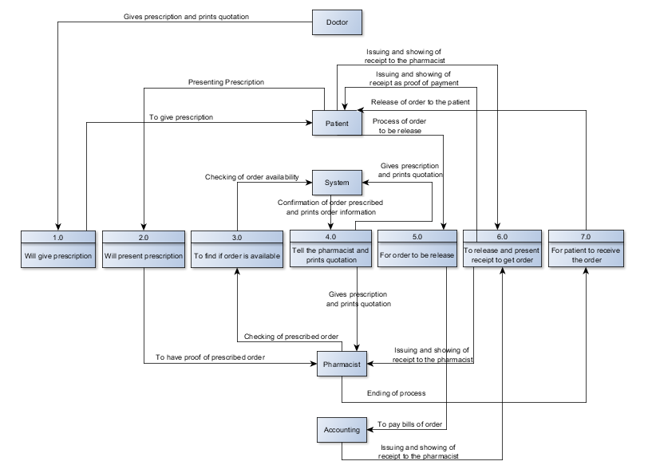

**DEPLOYMENT DIAGRAM**

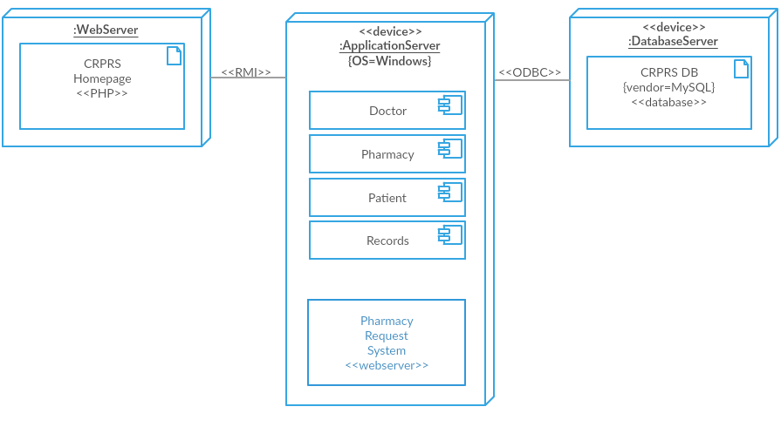

**INTERACTION OVERVIEW DIAGRAM**

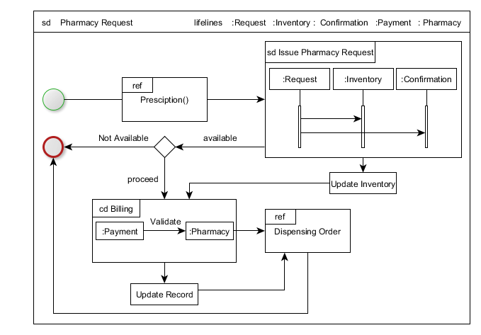

**OBJECT DIAGRAM**

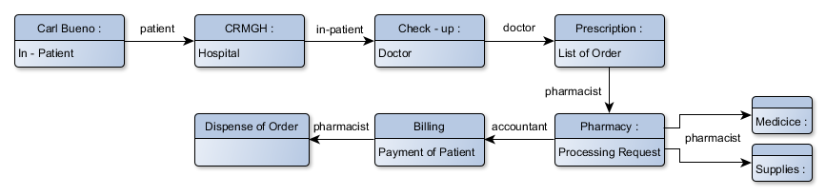

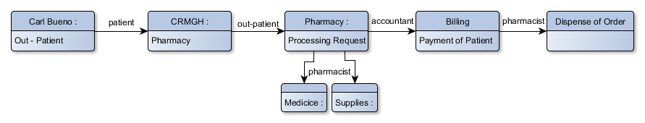

**PACKAGE DIAGRAM**

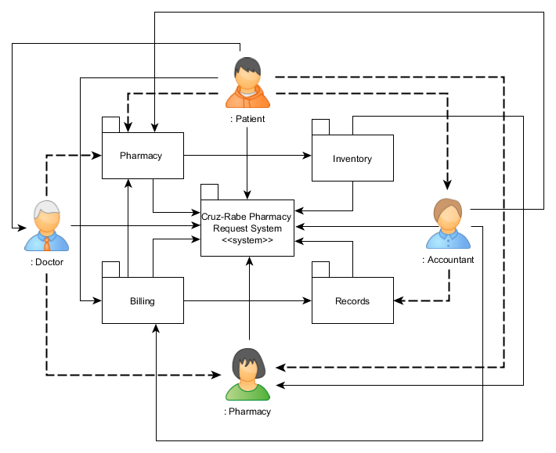

**SEQUENCE DIAGRAM**

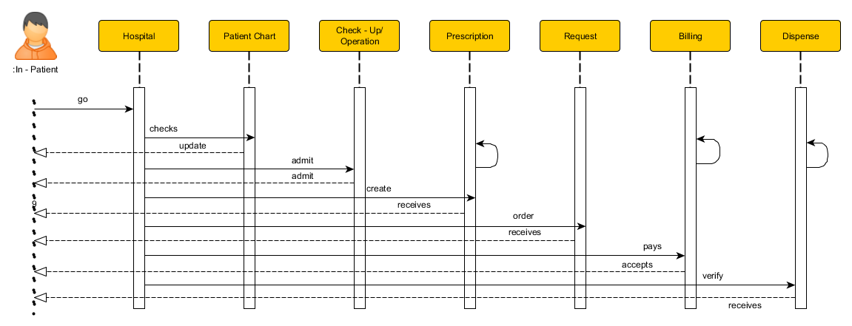

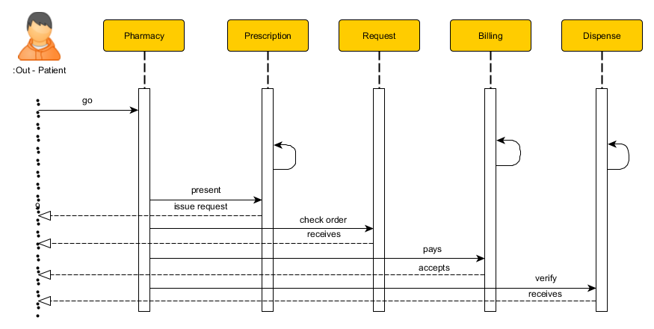

**STATE MACHINE DIAGRAM**

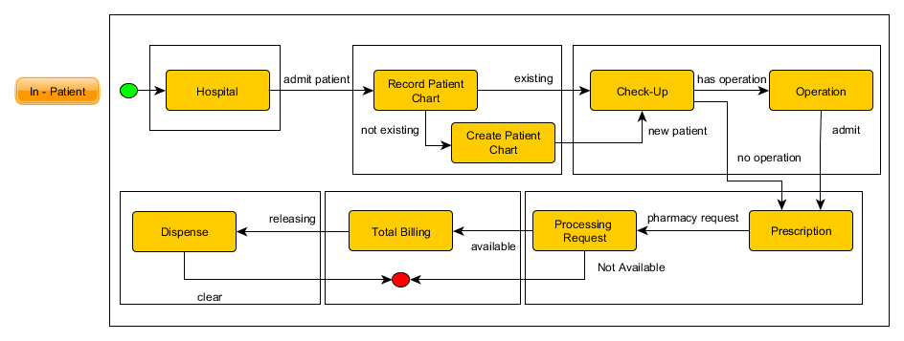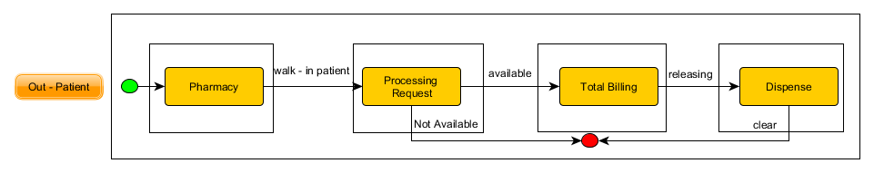

**TIMING DIAGRAM**

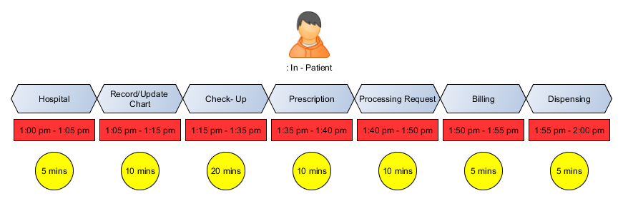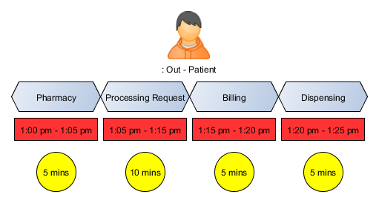

**USE CASE DIAGRAM**

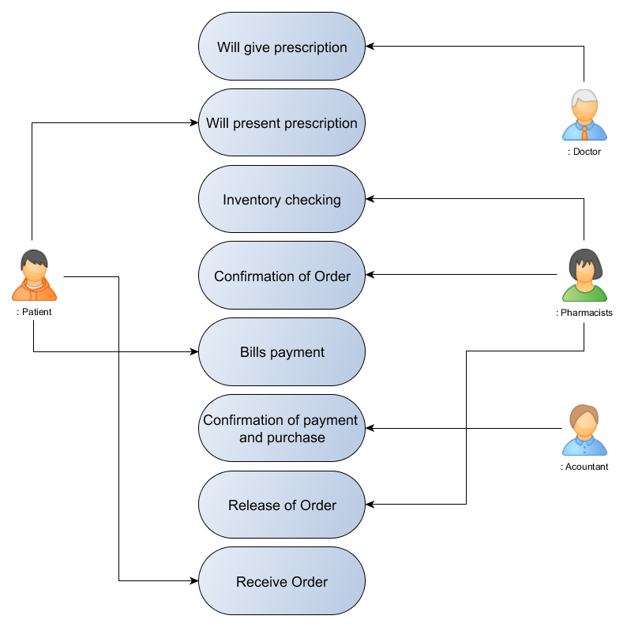

**ENTITY-RELATIONSHIP DIAGRAM**

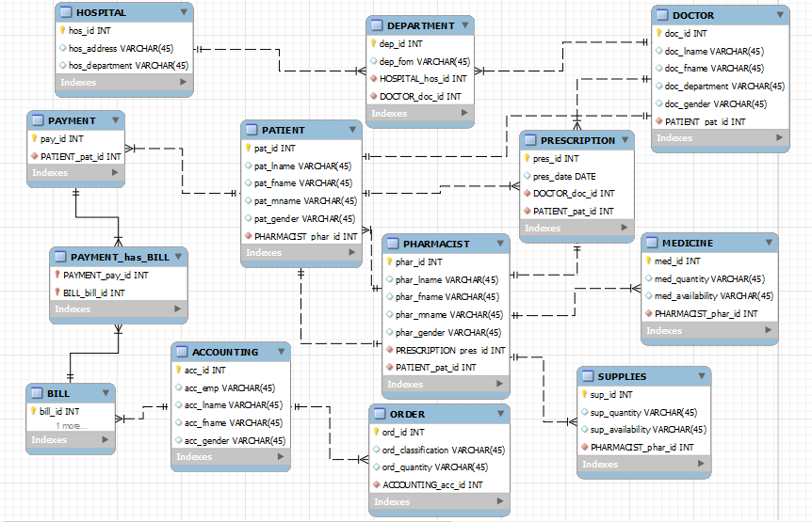

**DATA DICTIONARY**

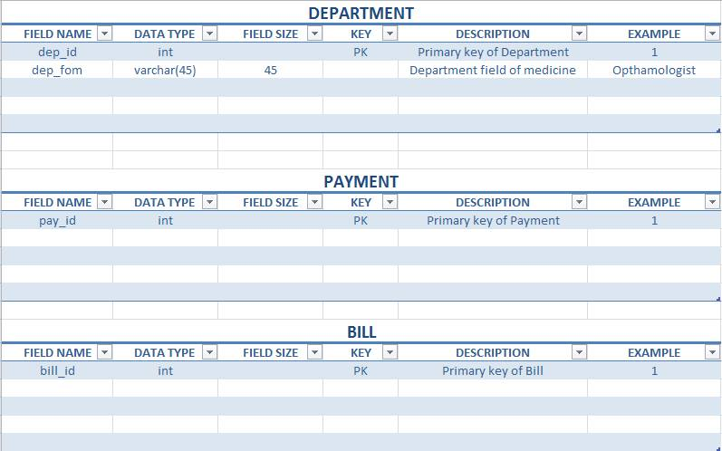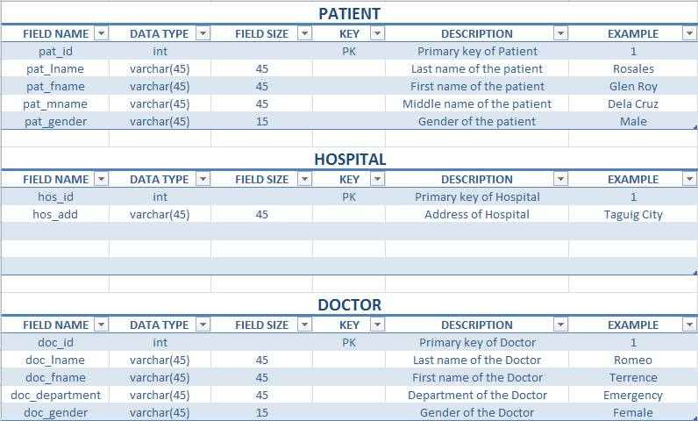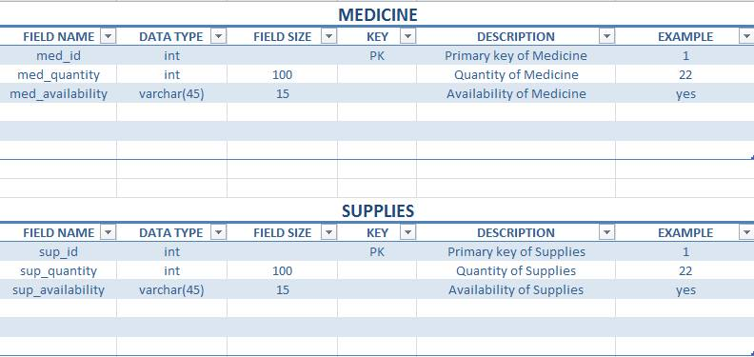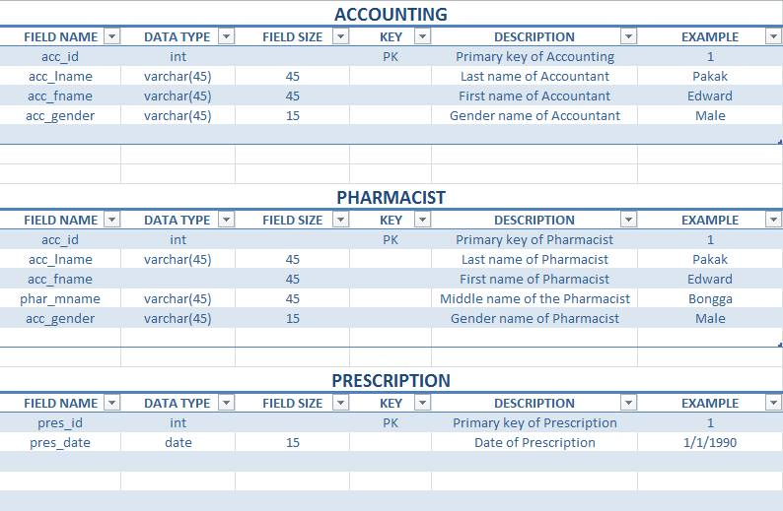

**PROTOTYPE APPLICATION SCREEN LAYOUT**

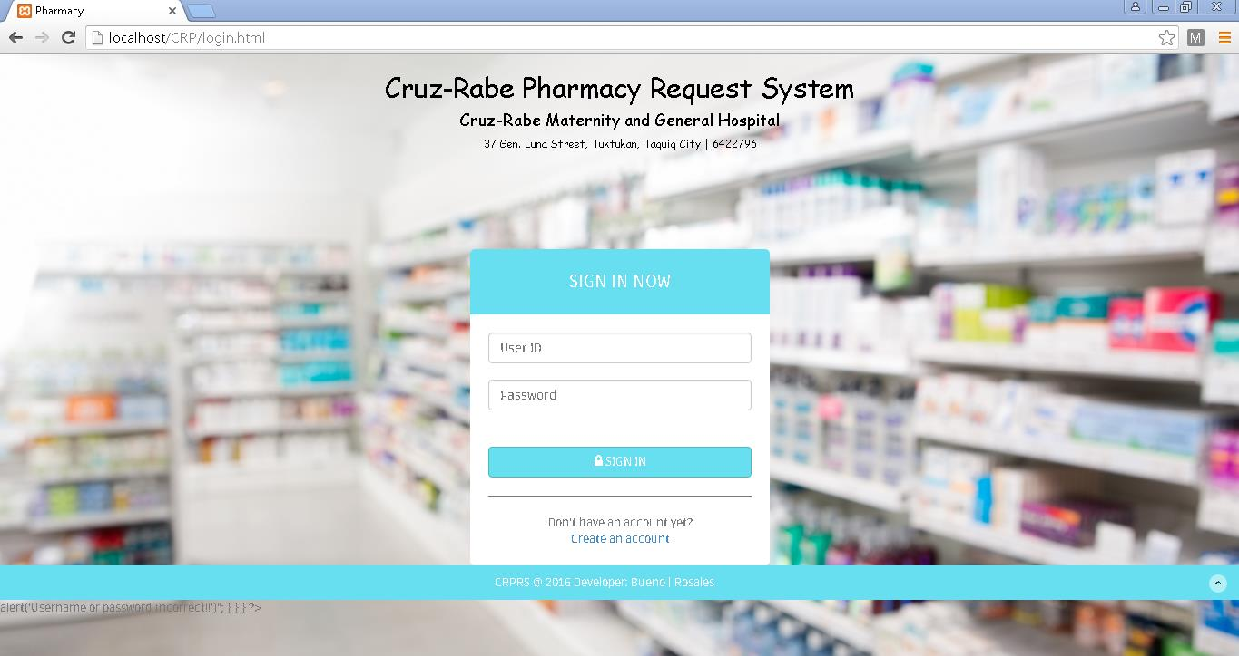

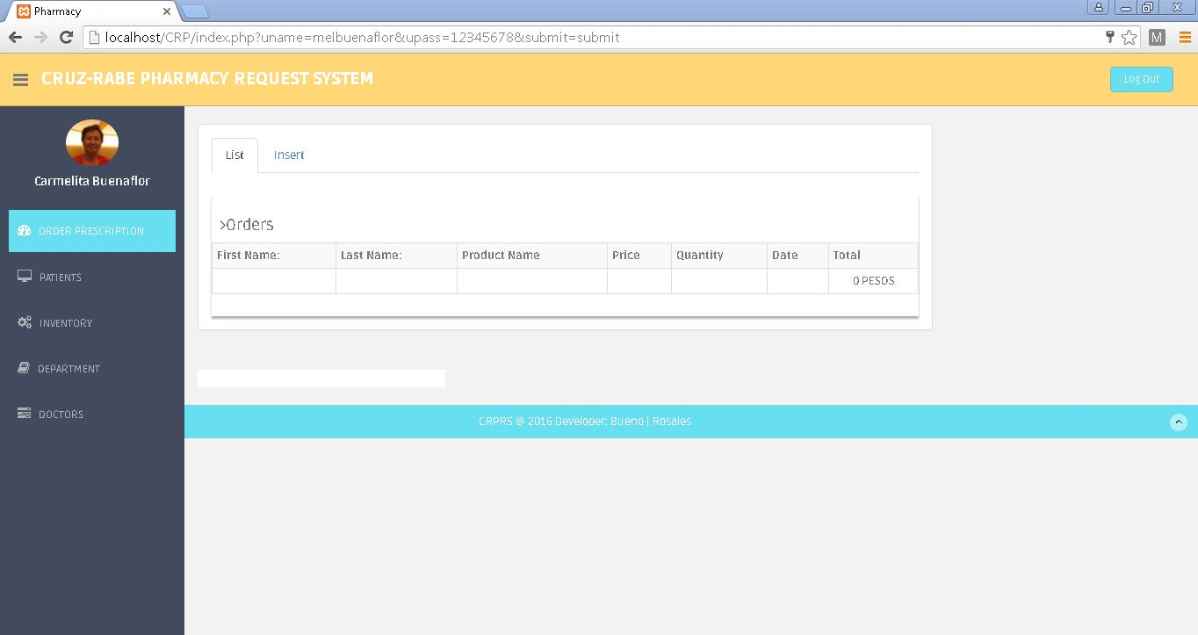

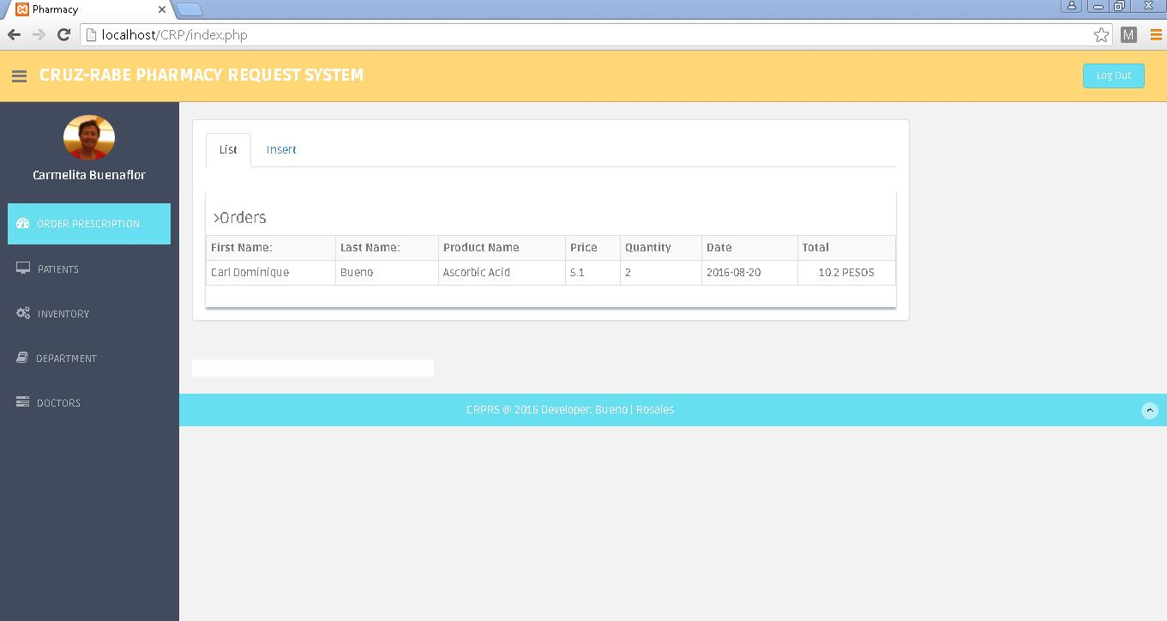

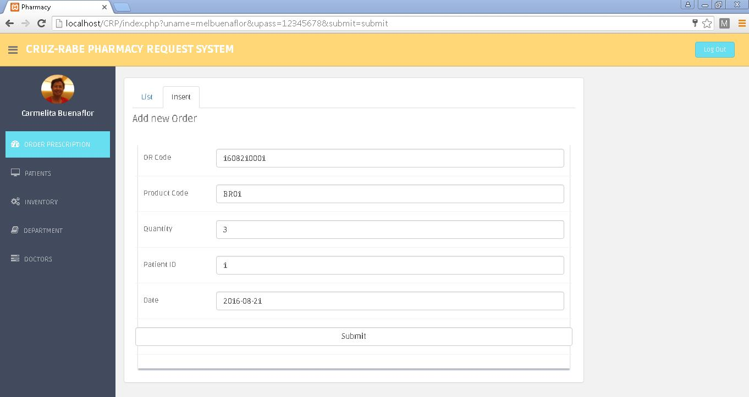

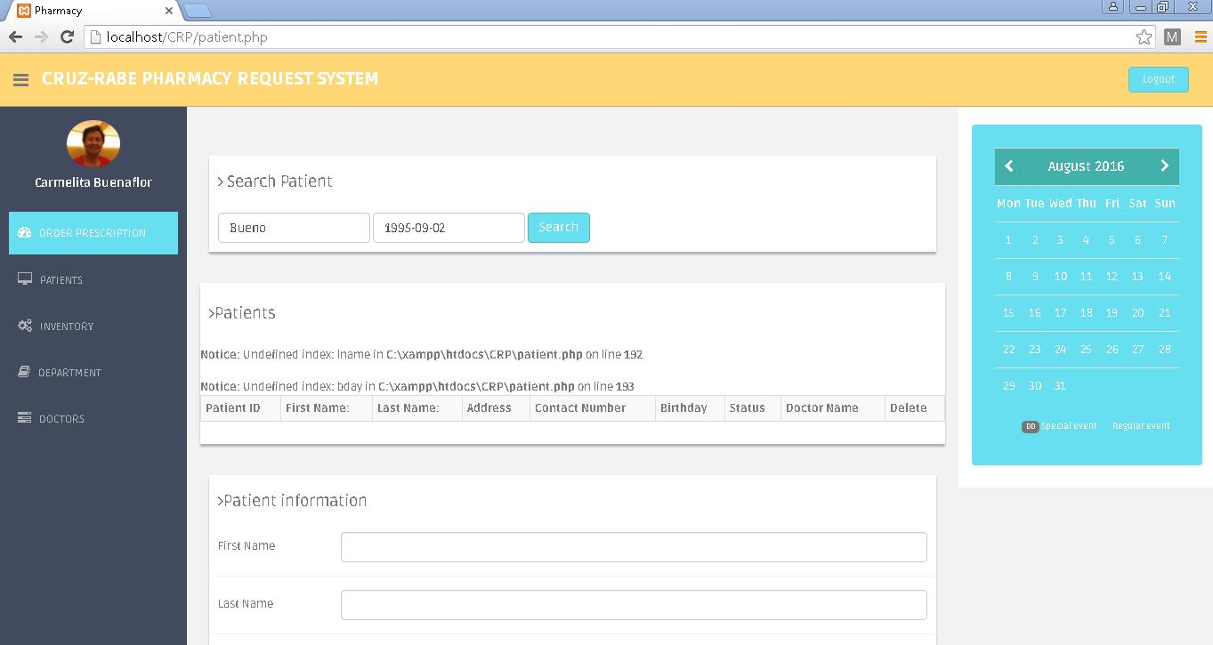

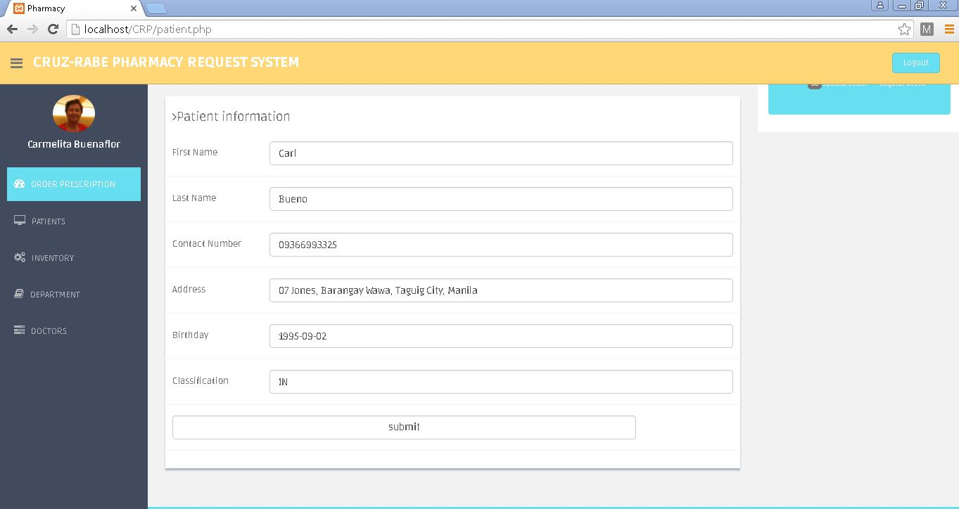

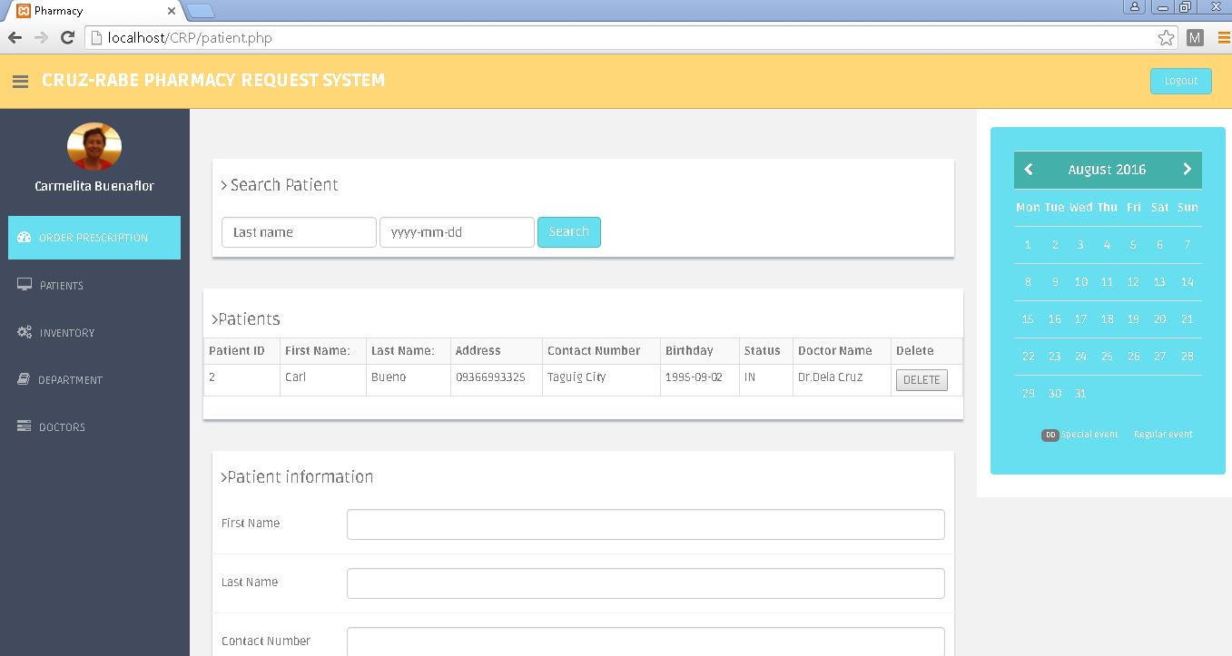

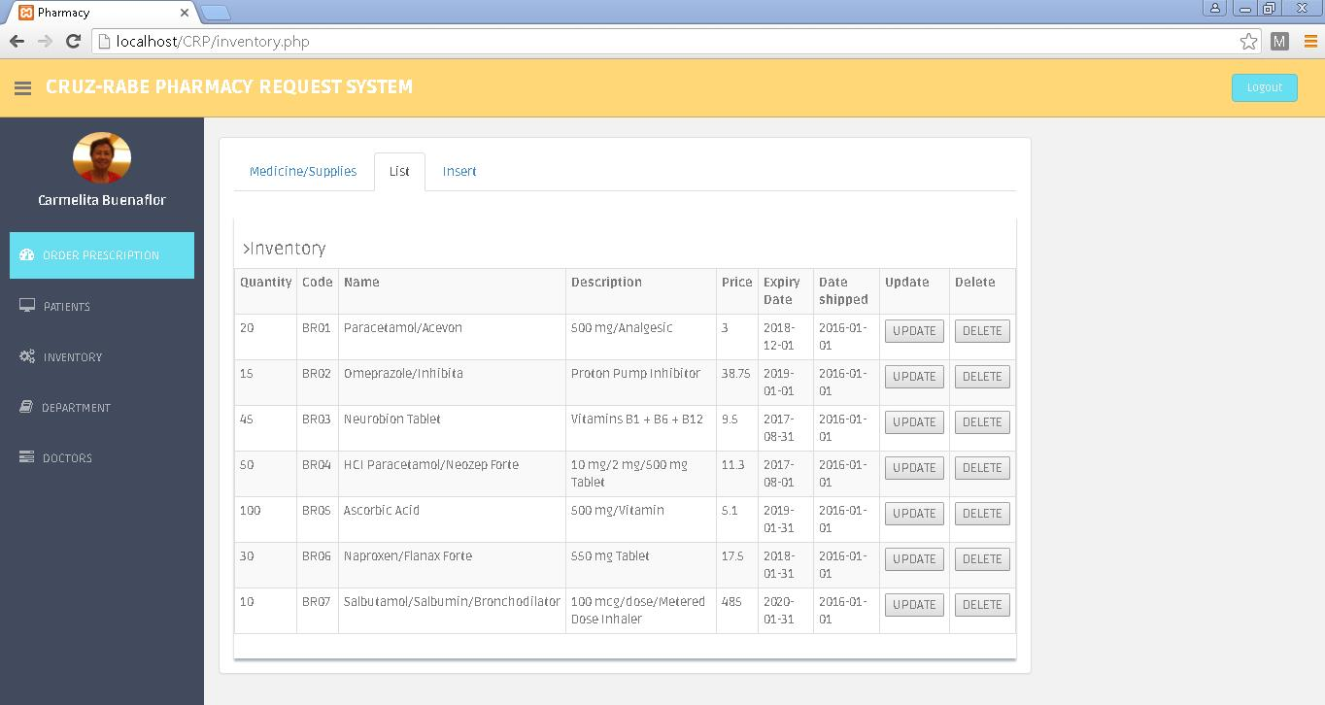

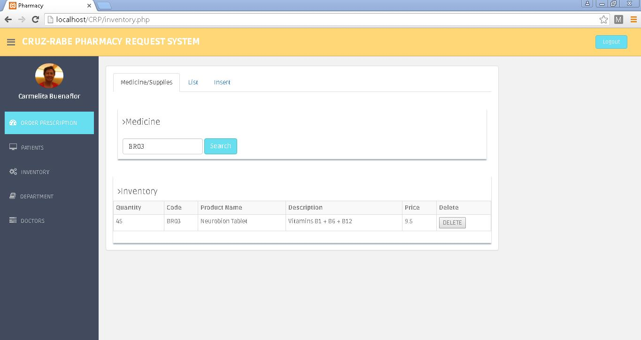

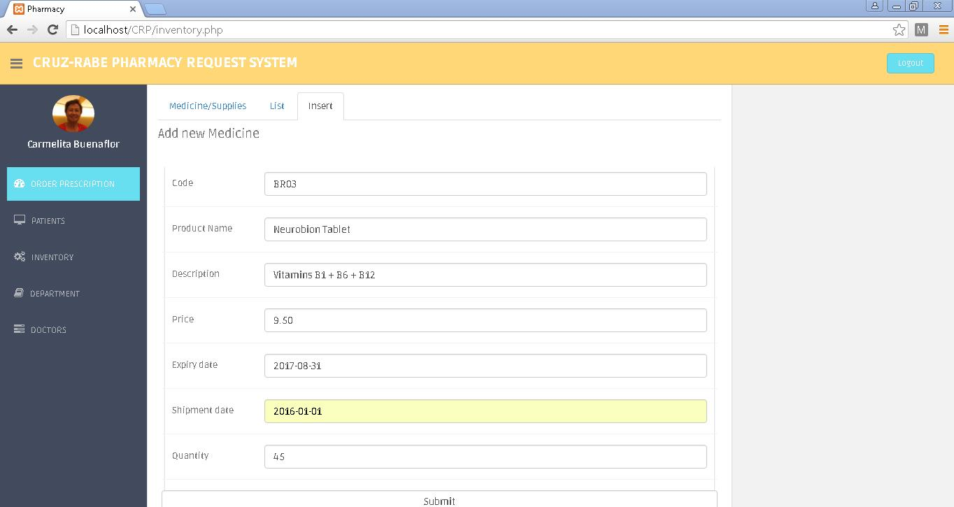

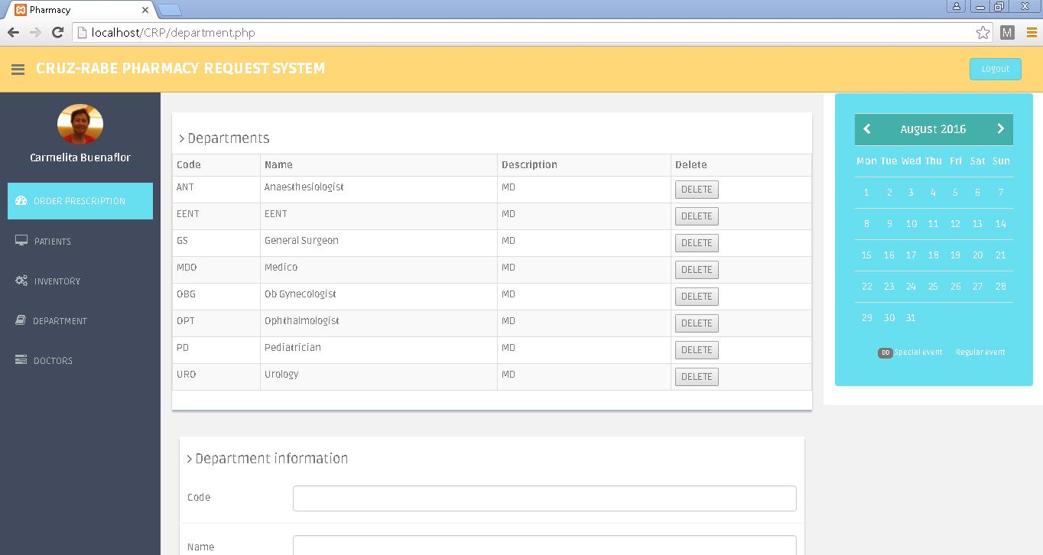

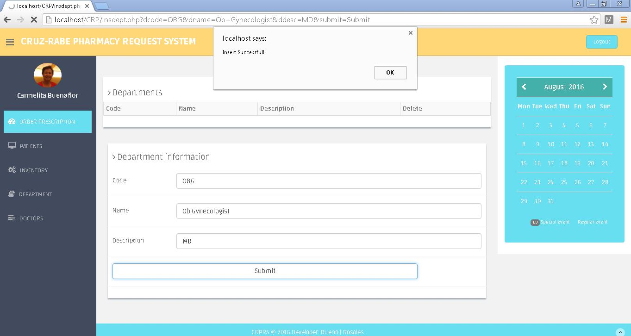

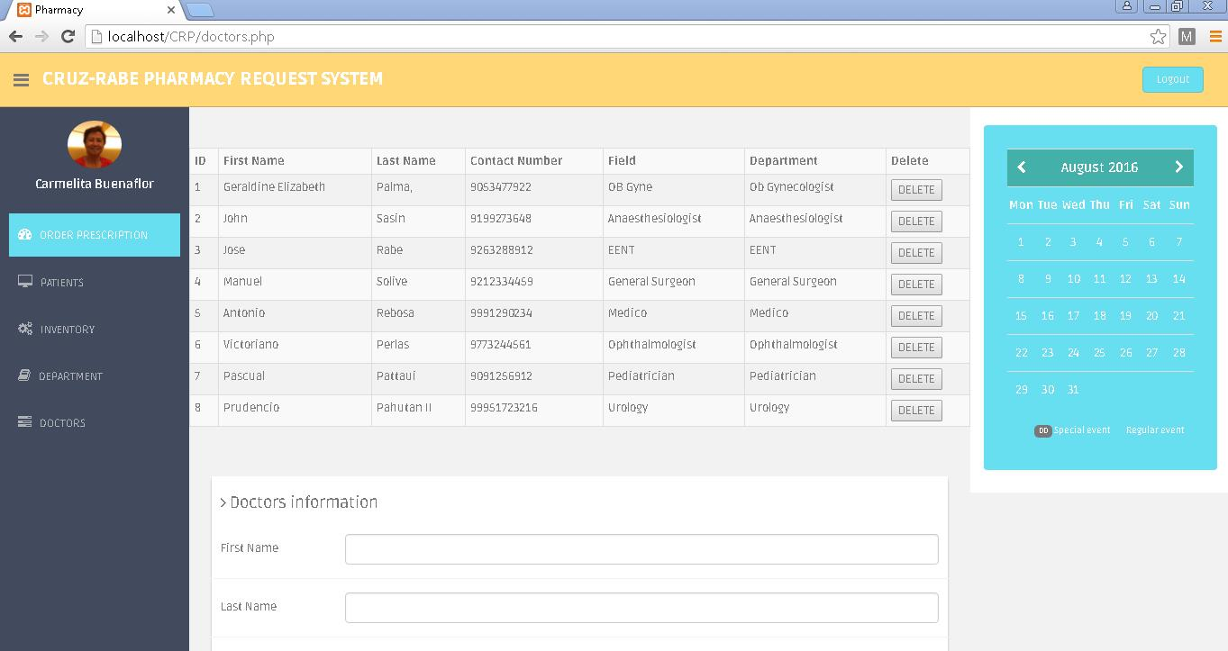



**SQL DATABASE SCREENSHOT**

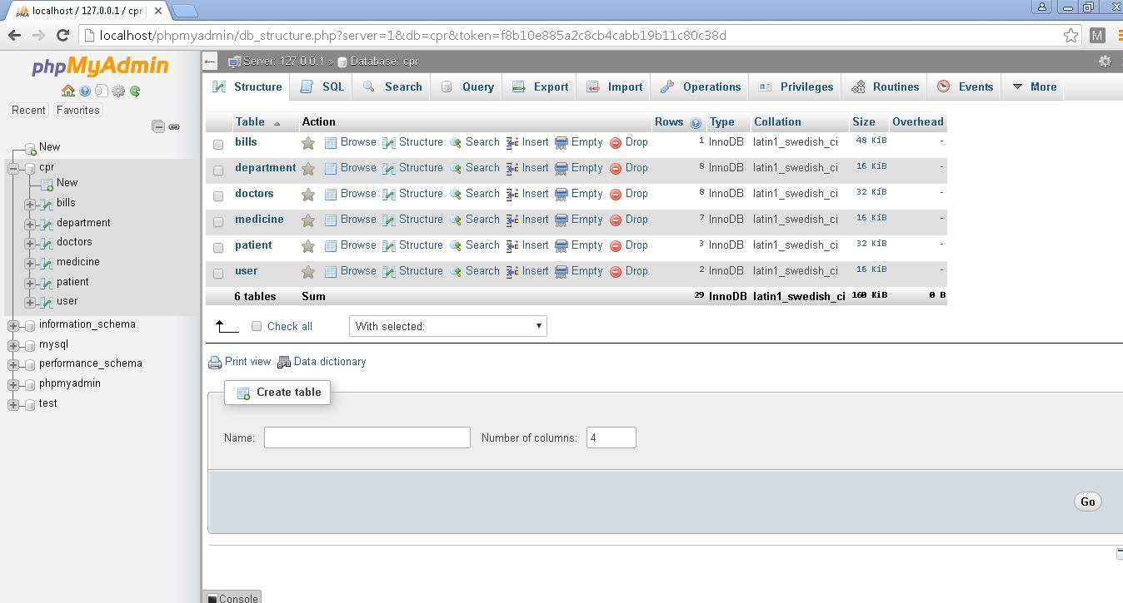

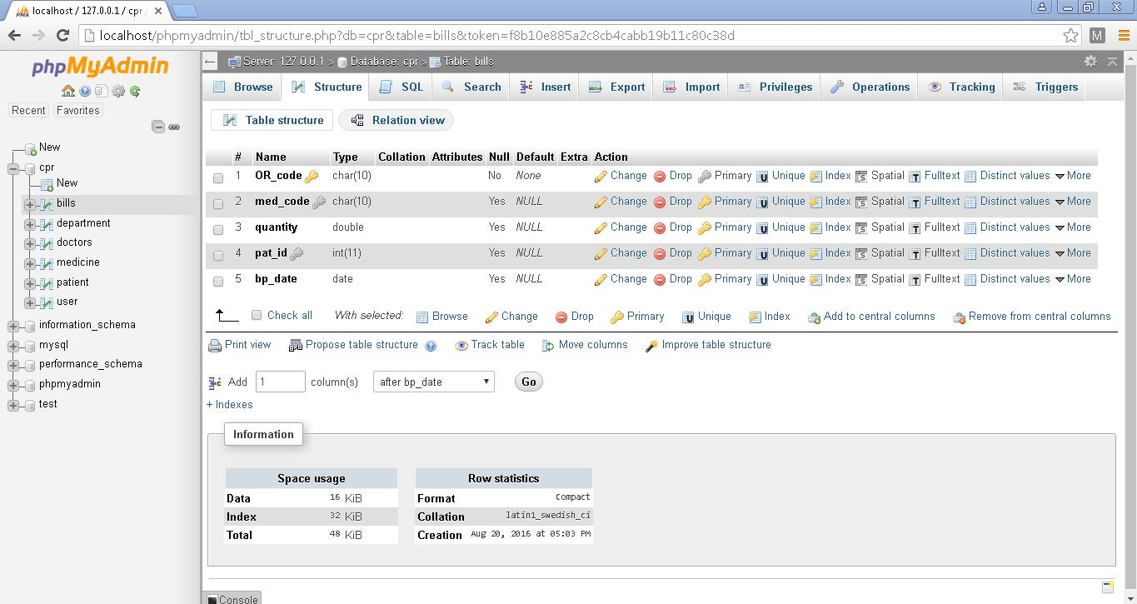

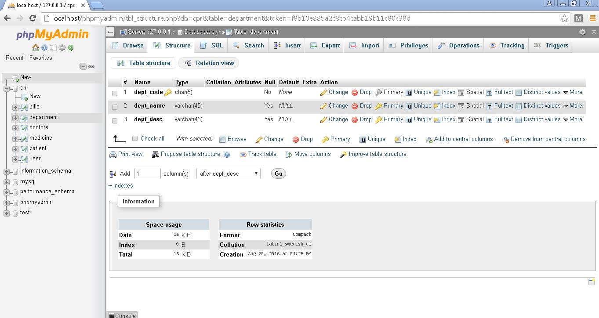

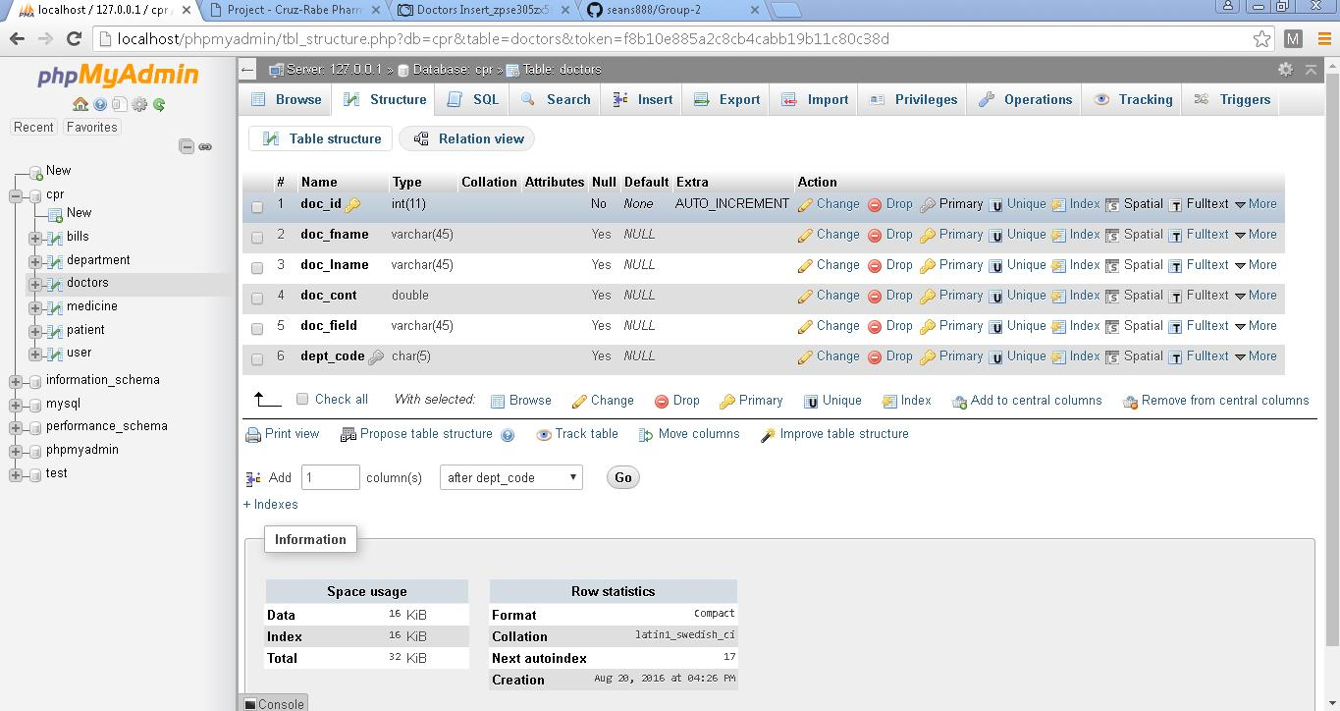

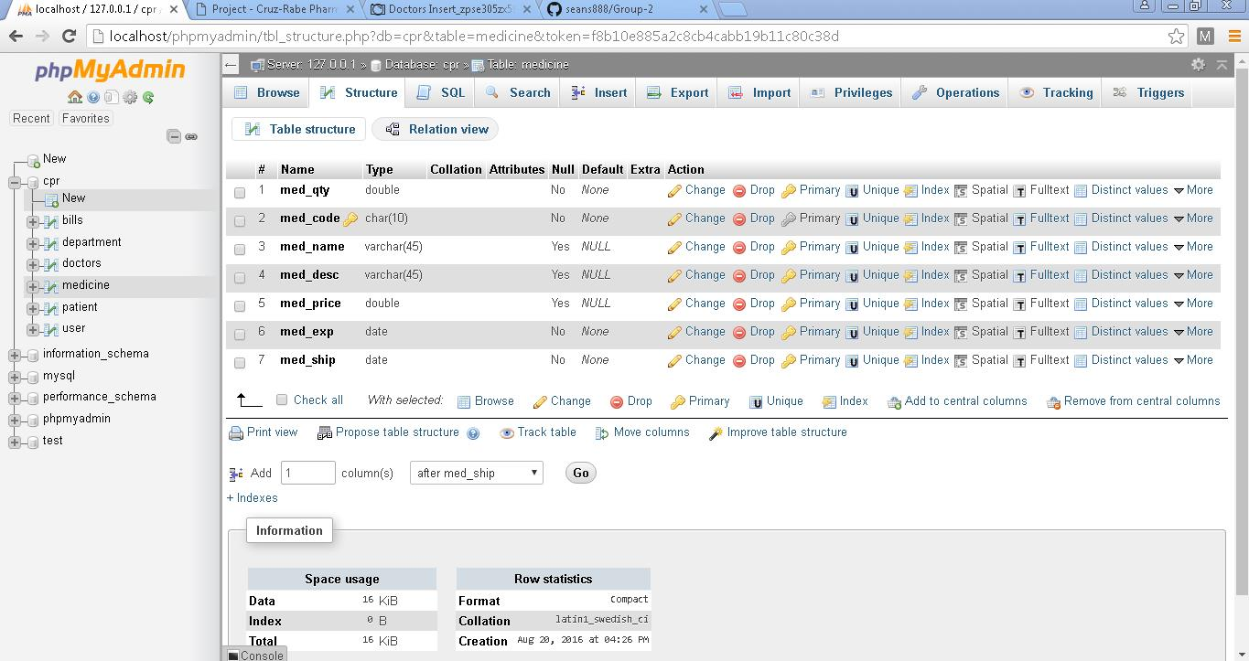

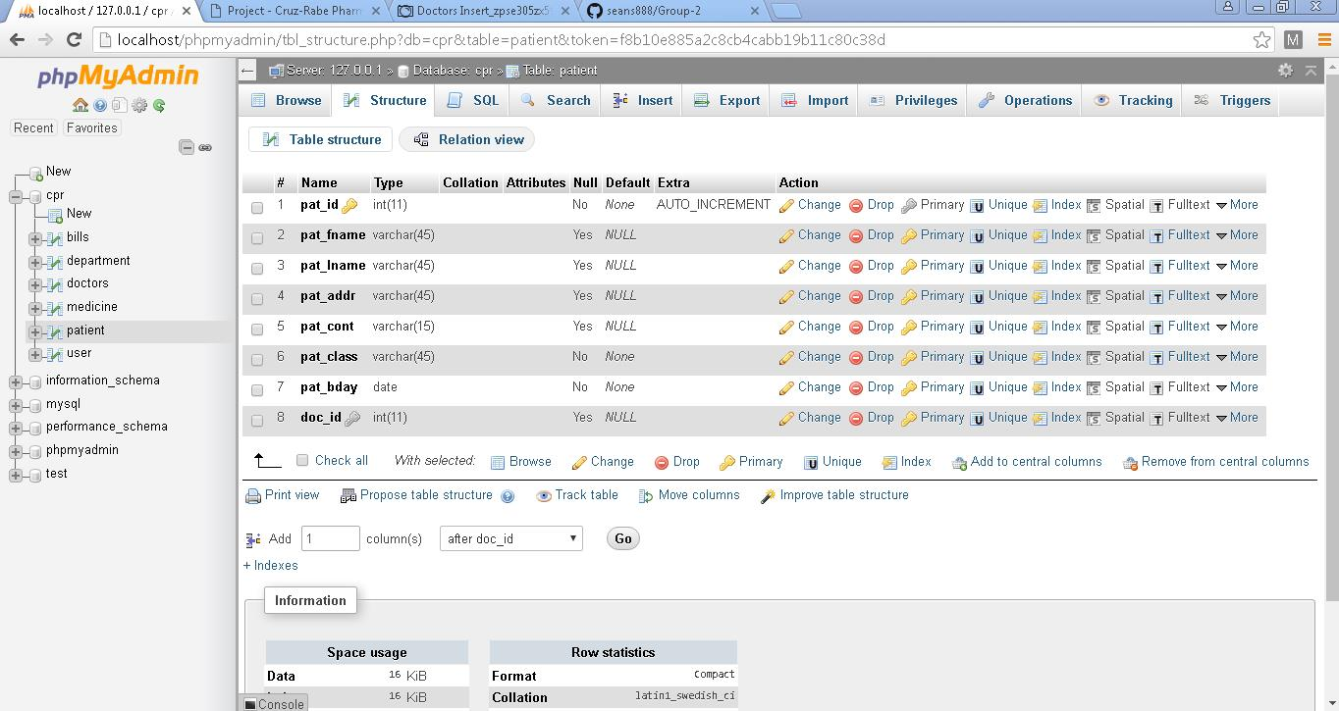

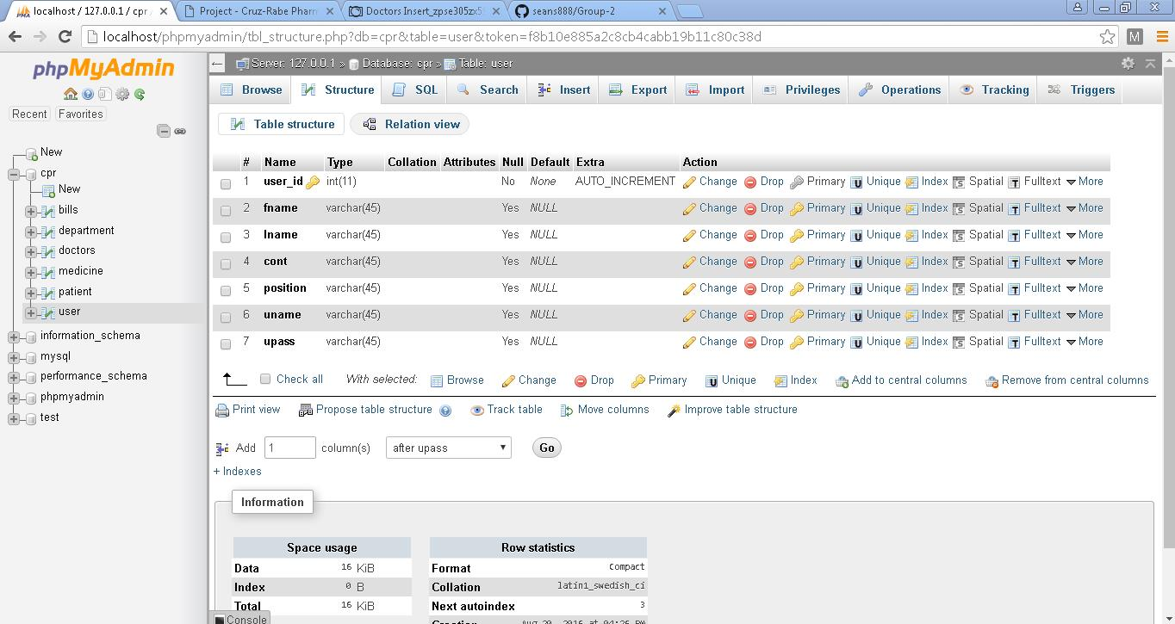

**Reference/s:**

* <http://projects2.apc.edu.ph/wiki/index.php/Project_-_Cruz-Rabe_Pharmacy_Request_System_%28CR-PRS%29_-106>
* <http://github.com>
* <http://moodle2.apc.edu.ph>
* <http://email.apc.edu.ph>
* <http://localhost/phpmyadmin>
* http://localhost/CRP
* <http://doh.gov.ph>
* <http://www.omnicell.com/About_Omnicell.aspx>
* <https://www.pioneerrx.com/web/pioneerrx>

**CARL DOMINIQUE P. BUENO**

07 Jones Street, Wawa, Taguig City

cpbueno@student.apc.edu.ph

+639366993325

**Education Background:**

June 2012 – Present **Asia Pacific College**

#3 Humabon Place, Magallanes, Makati City

*Bachelor of Science in Information and Technology Major in Mobile and Internet Technology*

June 2008 – March 2012 **Senator Renato Companero Cayetano Memorial Science and Technology**

**High School**

31st cor 51st Sts. Pamayanang Diego Silang, Ususan, Taguig City

June 2002 – March 2008 **Pillar of Truth Educational Foundation Inc.**

1632 M.L. Quezon Street, Taguig City

**Organizations:**

2014 **Philippine Red Cross**

Asia Pacific College

*Officer*

2012 **Junior Philippine Computer Society**

Asia Pacific College

*Member*

2010 **Philippine Robotics Club**

SRCCMSTHS

*Member*

 **GLEN ROY D. ROSALES**

BCDA Centennial Village, Bldg 1-217, Western Bicutan,

Taguig City

[gdrosales@student.apc.edu.ph](mailto:gdrosales@student.apc.edu.ph)

0997-206-5165

**Educational Background:**

June 2013 – Present **Asia Pacific College**

#3 Humabon Place, Magallanes, Makati City

*Bachelor of Science in Information and Technology Major in Mobile and Internet Technology*

June 2009 – March 2013 **Fort Bonifacio High School**

J.P Rizal Ext., West Rembo, Makati City

June 2003 – March 2009 **Fort Bonifacio Elementary School**

J.P Rizal Ext., West Rembo, Makati City

**Organizations:**

2015 – 2016 **The Good People of Society**

*Former President/Member*